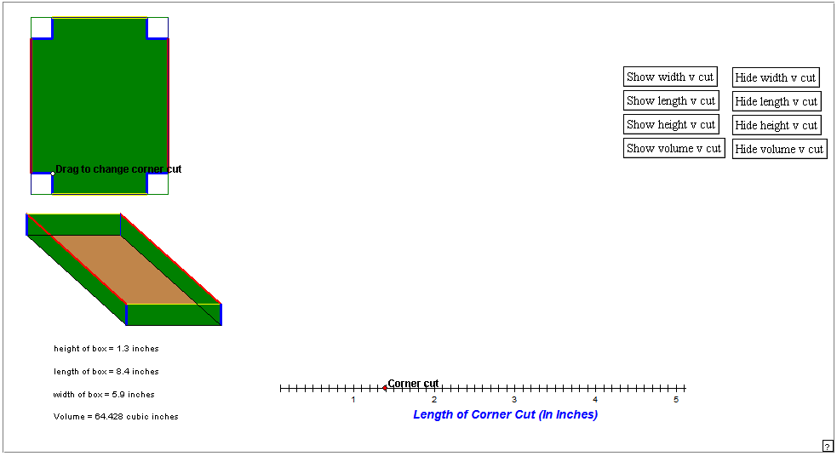
Instructors Comments: This applet can be used to help the students create a dynamic image of the box problem. The mouse can be used to drag the red button which will vary the size of the cutout. The box underneath will vary as the cutout is dragged. With this applet the instructor also as the choice of which quantity or quantities should be graphed as a function of the length of the cutout. Students should make conjectures about the shapes of the graphs before they are displayed and give reasoning for their conjectures. After the graph is shown, if their conjectures are incorrect, have them give reasoning for the correct version.

