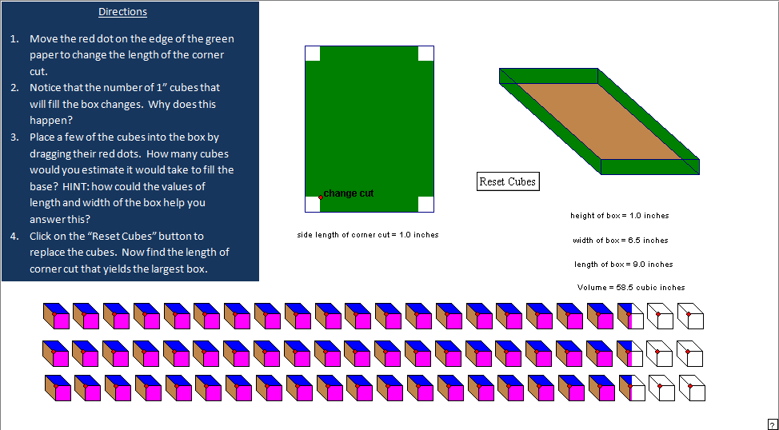

Instructors Comments: This applet can be used to help the students create a dynamic image of the box problem. The mouse can be used to drag the red button which will vary the size of the cutout. The box to the right will vary as the cutout is dragged. In addition, each cube represents a unit of volume. The students can get an idea of how the volume accumulates by watching it simultaneously accumulate in the boxes. An additional feature of this applet is that the boxes can be dragged by clicking on the corner with the red dot and placed in the box created by cutting out a corner. This gives the students a method of verifying that they represent the same volume.

