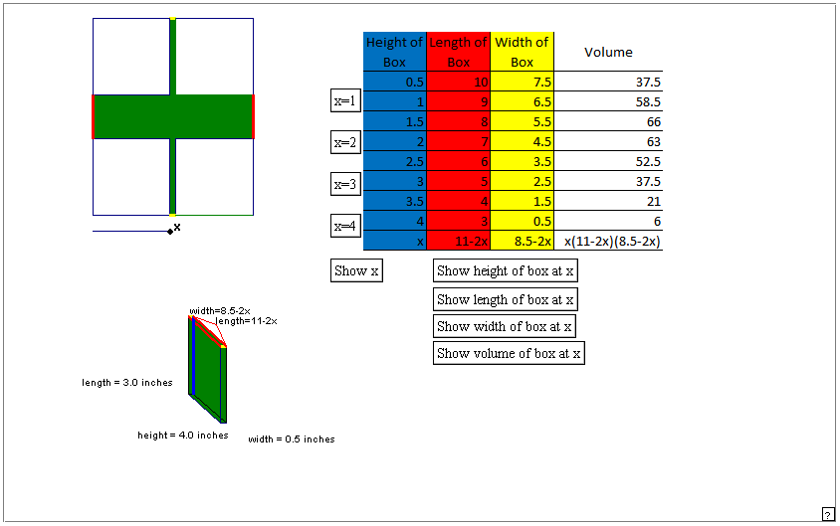
Instructors Comments: This applet can be used to show how the formula to calculate the volume of the box for a given cutout length can be generated using some actual values for the cutout. The instructor can either have the students generate the data first then verify it using the applet, or walk through the applet with the students. The students should be allowed to make a conjecture for the general case before it is revealed.

